2015 Mini Paper Initiative to Expand Presentations Made at the Harold W. Borns Symposium to Wider Audience
Andrei V. Kurbatov¹, Betty Lee¹, Paul A. Mayewski^{1, 2}
- Climate Change Institute, University of Maine.
- School of Earth and Climate Sciences, University of Maine.
Abstract: This year we have a new initiative at the Climate Change Institute, University of Maine. We would like to disseminate research presented at the annual Harold W. Borns symposium to a wider audience. This template should help you to create a publication-ready one-page mini-paper.

Why a mini paper:
The Climate Change Institute (CCI) is an interdisciplinary research unit organized to conduct research and graduate education funded by public and private sources. It is a requirement for the CCI students and faculty to report annually about research and educational activities.
During the last 19 years at the annual CCI symposium faculty and students have presented updates about their research. During recent years (see Fig. 1) the number of presentations presented at the symposium rose dramatically. In 2010, a new two minutes research presentation option became available to faculty members in order to keep the symposium duration within two days.

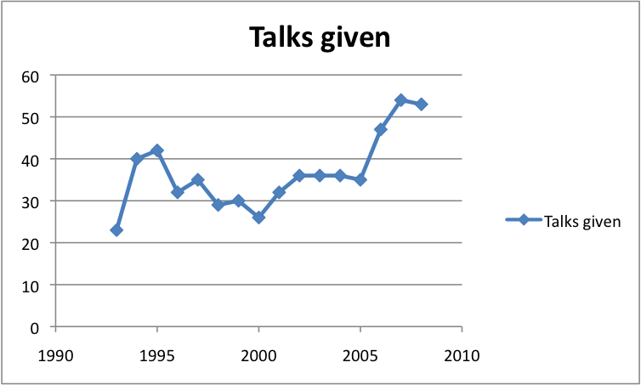
Fig. 1. Number of abstracts submitted per year.
A few years ago during the Fall CCI meeting the faculty and staff approved an initiative to publish one page self contained mini-papers for the Borns Symposium following standards utilized by several European research centers.
CCI uses Open Conference Systems for abstract and paper submissions. To mitigate potential conflicts for papers submitted for publications users can arrange with the CCI conference organizing committee to delay or delete non-CCI open access to mini-papers. To simplify the submission process please use the format presented here. Paper title, authors names, affiliations and captions for figures and tables should have separate document styles (eg. Table 1) This document can be used as an “MS Word Template” but users may create similar looking documents in any text editor. We accept PDF or MS Word documents.

Table 1. Fonts used for document styles.
Style | Font
Title | Arial, 12, Bold
Authors | Arial, 11
Affiliations | Arial, 10, Italic
Captions | Arial, 9
Normal text | Arial 10
To insert text. To insert text into the different sections, copy your text into the Clipboard and replace existing text. Use the “Edit/Paste Special” option to preserve text formatting.
To prepare graphics. For graphics refer to the AGU website.
Acknowledgements: Please include source of support for the research.
Bibliography: Please use the Chicago Manual of Style for references.

